The Helsinki, Rotterdam and Marshall Scoring Systems in Prediction of Long-Term Outcome in Patients with Traumatic Brain Injury: Prospective Study

Abstract
Background: Traumatic brain injury (TBI) results from external forces disrupting brain function, leading to structural damage and neurological deficit. Comparing the Helsinki CT score to the CT screening systems of Rotterdam and Marshall allowed us to examine its capacity to independently predict the long-term prognosis of TBI patients.
Methods: This prospective observational cohort study was carried out on 300 cases with TBI that was admitted for surgical or conservative treatment at the Neurosurgery Department and/or Neurosurgery Intensive Care Unit in Benha University Hospitals. All patients were subjected to clinical evaluation and radiological evaluation.
Results: Regarding unfavorable outcomes, All three scores independently predicted poor prognosis (cutoffs: >2 for Rotterdam, Marshall and Helsinki). Regarding mortality, Higher cutoffs indicated elevated risk (>3 for Rotterdam/Marshall and >5 for Helsinki). Regarding functional decline: Significant correlation with worsening mRS scores at follow-up
defined cutoff values and statistical significance (*p*<0.05). Results show that in multiple regression analysis, Rotterdam, Marshall, and Helsinki Scores are significant predictors for change in Modified Rankin score in the study participants follow up.
Conclusions: At cutoff values of >2, >2, and >2 respectively, the Rotterdam Score, Marshall Score, and Helsinki Score are significant predictors of unfavorable outcomes in TBI. Rotterdam Score, Marshall Score, and Helsinki Score are significant predictor of mortality in traumatic brain injury, at a cut-off value of >3, >3, and >5 respectively.
The Helsinki score demonstrates comparable prognostic accuracy to established systems. All three tools effectively stratify TBI patients by mortality risk and long-term disability, supporting their integration into clinical decision making. Rotterdam, Marshall, and Helsinki Scores are significant predictors for the change in Modified Rankin score at the follow-up in TBI.
Keywords: Helsinki Scoring System, Marshall Scoring System, Rotterdam Scoring System, Traumatic Brain Injury.

Introduction

Symptoms of brain disease or loss of brain function can result from a blow to the head, a condition known as traumatic brain injury (TBI) ^{[1]}. Nearly half of the world's population will, at some point in their lives, suffer a TBI, and an estimated 50 million people are affected annually. ^{[2]}. It ranks first among causes of death and disability among British citizens younger than 40 ^{[3]}. Furthermore, low- and middle-income nations have significantly higher rates of mortality and morbidity. It is estimated that TBI incurs approximately 400 billion US dollars annually in the global economy, which is equivalent to 0.5% of the gross world product ^{[2]}.
Incorporating data from patients to forecast outcomes, prognostic models are statistical models that are anticipated to be more precise than fundamental clinical predictions ^{[4]}.
The many features of computed tomography (CT) imaging have led to the development of a plethora of CT classification schemes. According to Marshall's CT system ^{[5]}. In 1991, the term was introduced and is defined by three primary characteristics: a mass lesion, midline shift or displacement and the status of the peri mesencephalic cisterns. There were limitations to the study's capacity to predict patients' outcomes, even though its major objective was to assess the severity of TBI. In 2005, the Rotterdam CT score was developed to facilitate the diagnosis and prognosis of patients with brain lesions the result of TBIs. Diagnostic criteria that comprise the Rotterdam CT score include characteristics of Marshall CT score plus ruptured subarachnoid hemorrhage (SAH), epidural hematoma (EDH), and intraventricular hemorrhage (IVH) ^{[6]}. External validation has not yet been conducted for either methodology, even though they have both demonstrated satisfactory performance in their respective development populations. Instead of anticipating unfavorable outcomes, the Rotterdam score was devised to predict mortality. It has shown outstanding performance and has been validated externally ^{[7-9]}.
The Helsinki CT Score System was re-evaluated and presented by Rahul et al. in 2014, who utilized data from 869 patients. According to the prognostic CT model, mortality and adverse neurologic outcomes were anticipated in the long term. In addition to emphasizing the predictive value of intraventricular hematomas (IVH), Rahul et al. distinguished between subdural hematomas (SDH), intracerebral hematomas (ICH), and extradural hematomas (EDH). In addition, they were the first to incorporate the status of suprasellar cisterns (SSCs) into a CT scoring system, which can be classified as normal, compressed, or obliterated. This replaced the previous use of the term "basal cisterns." Possible ratings range from -3 to 14 ^{[10]}. (Figure 1,2 and 3) By comparing the Helsinki CT score to the Marshall and Rotterdam CT scores, this research aimed to determine if it can independently predict the long-term prognosis of TBI patients.
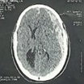
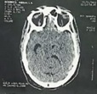
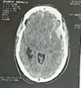

Figure1: shows CT brain of 55 years old male patient presented by head trauma (The Helsinki Score 11/14: Obliterated Cistern:5, Subdural Hemorrhage 2, Intracerebral Hemorrhage 2, mass lesion>25cm 2), (The Rotterdam Score 6/6 : Absent basal cistern:2, Midline shift more than 0.5cm:1 , Absent epidural Hematoma: 1 Traumatic SAH:1), The Marshall Score VI: High or mixed density lesions >25 cm3 not surgically evacuated)
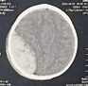
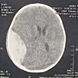
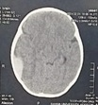

Figure2: shows CT brain of male infant 9 months old presented to us 5 hours after falling from height (The Helsinki Score 0/14 : Compressed Cistern:1, Extradural Hemorrhage -3, mass lesion>25cm:2), (The Rotterdam Score 2/6 : Compressed basal cistern:1, Midline shift more than 0.5cm:1 , epidural Hematoma: 0), The Marshall Score IV: High or mixed density lesions >25 cm3 surgically evacuated)

a) | 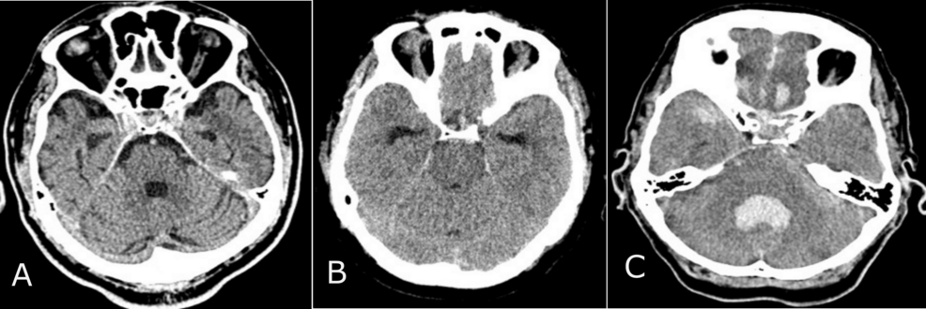
b) | 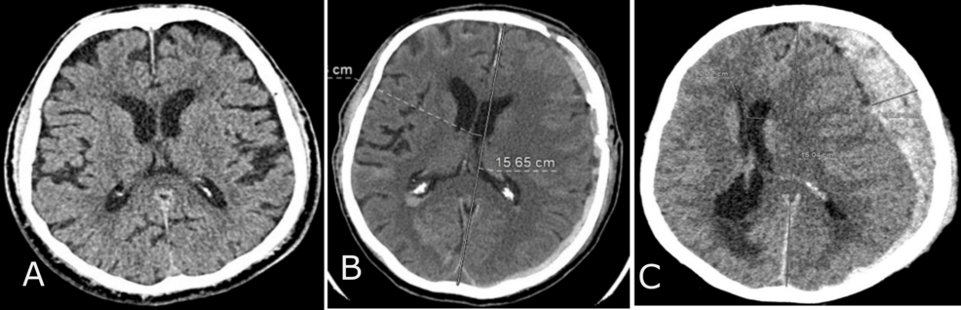
c) | 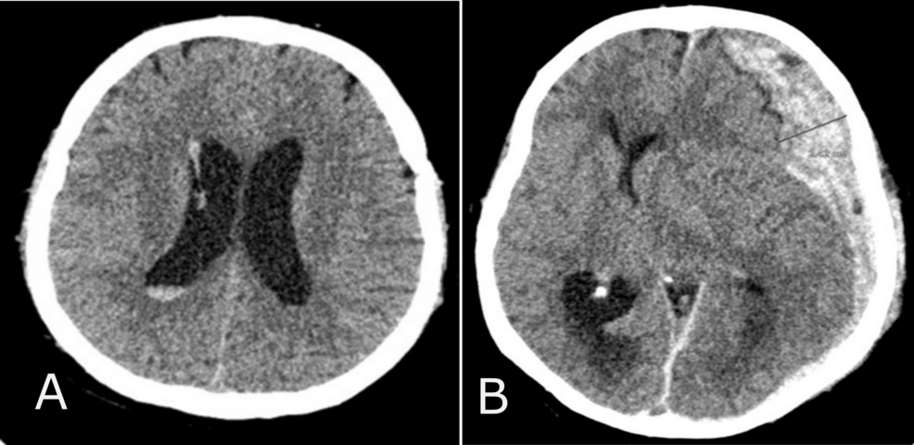
d) | 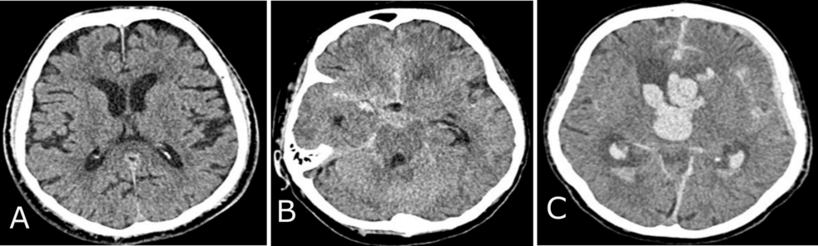
Figure 3: a) CT normal findings of basal cisterns (A); compressed B); absent (C), b) Midline shift normal findings (A); midline shift ≤5 mm (B); midline shift >5 mm (C), c) Epidural space normal findings (A); epidural mass lesion acute epidural hematoma (B), d) Intraventricular and subarachnoid space normal findings (A); subarachnoid hemorrhage (SAH) (B); intraventricular hemorrhage (IVH) and SAH (C)

Patients and Methods
This prospective comparative observational cohort study was carried out on 300 cases with TBI that was admitted for surgical or conservative treatment at the Neurosurgery Department and/or Neurosurgery Intensive Care Unit in Benha University Hospitals from November 2023 to November 2024. The patients provided written consent that was informed. The study was conducted with the approval of the Ethics Committee of the Faculty of Medicine at Benha University Hospitals (Approval code: MS 21-12-2023).
Inclusion criteria were recent trauma (<24 hours) and initial head CT scan within 24 hours after injury showed intracranial brain pathology before any neurosurgical intervention, or any artificial device had been inserted into the brain.
Exclusion criteria were cases with non-traumatic brain insult, cases presented to hospital with old Trauma (>24 hours) and/or initial head CT scan done after 24 hours of TBI, Poly-traumatized Patients with major system affection that could affect mortality other than central nervous system and patients with initial CT brain showed no intracranial pathology.
The clinical evaluation of all patients included the following: [personal history, special habits of medical importance and pre-injury function, including age, sex, occupation, history of present illness and mechanism of injury, past medical history and medical comorbidities, neurological examination of cranial nerves, motor and sensory system, and Glasgow Coma Scale examination].
Radiological evaluation
CT brain scan findings were from our Neurosurgery Department storage system. All CT scans were performed with the same device, and same protocol parameters.
Neurosurgery department clinicians evaluated admittance characteristics, which were subsequently obtained from electronic records. In accordance with the Helsinki classification system, neurosurgeons classified patient head CT scans (Table. 1) ^{[11]}, Rotterdam(Table. 1) ^{[12]}, and Marshall (Table. 1) ^{[13]} CT Score systems.
Table 1: Helsinki, Rotterdam and Marshall Computerized Tomography Score.
The Helsinki Score
Variable |  | Type |  | Score
Mass lesion type(s) |  | Subdural hematoma |  | 2
 |  | Intracerebral hematoma |  | 2
 |  | Epidural hematoma |  | -3
Mass lesion size > 25 ${cm}^{3}$ |  |  |  | 2
Intraventricular haemorrhage |  |  |  | 3
Suprasellar cisterns |  | Normal |  | 0
 |  | Compressed |  | 1
 |  | Obliterated |  | 5
Sum score |  | Sum score |  | -3 to 14
The Rotterdam Score
CT finding |  | Definition | Score
Basal Cistern |  | Normal | 0
 |  | Compressed | 1
 |  | Absent | 2
Midline shift |  | No or less than 5 mm | 0
 |  | Shift more than 5 mm | 1
Epidural Mass Lesion |  | Present | 0
 |  | Absent | 1
Intraventricular Hemorrhage or Traumatic SAH |  | Present | 1
 |  | Absent | 0
Sum Score |  | Score +1
The Marshall Score
Classification | Definition
Diffuse injury I (no visible pathology) | No visible intracranial pathology
Diffuse injury II | Midline shift of 0 to 5 mm  Basal cisterns remain visible  No high or mixed density lesions >25 cm3
Diffuse injury III (swelling) | Midline shift of 0 to 5 mm  Basal cisterns compressed or completely effaced  No high or mixed density lesions >25 cm3
Diffuse injury IV (shift) | Midline shift >5 mm  No high or mixed density lesions >25 cm3
Evacuated mass lesion V | Any lesion evacuated surgically

The Modified Rankin score was used to determine the neurological outcome based on outpatient clinic follow-ups by neurosurgeons six months after the injury (Table. 2) ^{[14]}.
Table 2: Modified Rankin score
Score | Definition
0 | No symptoms
1 | No significant disability despite symptoms; able to carry out all usual duties and activities
2 | Slight disability; unable to carry out all previous activities, but able to look after own affairs without assistance
3 | Moderate disability; requiring some help, but able to walk without assistance
4 | Moderately severe disability; unable to walk and attend to bodily needs without assistance
5 | Severe disability; bedridden, incontinent and requiring constant nursing care and attention
6 | Death

Statistical analysis:
We used version 29 of IBM's Statistical Package for the Social Sciences (Chicago, IL, USA) for our statistical work. Quantitative data, such as age, was shown using the mean and standard deviation (SD), whereas categorical variables, like sex, were expressed using the frequency and percentage. Using receiver operating characteristic (ROC) curve analysis, we calculated the cut-off scores for each of the three criteria—the Marshall, the Rotterdam, and the Helsinki—based on patients' head CT scans in order to predict poor outcomes and mortality. Using multiple linear regression analysis and standardized β regression coefficients, the significance of the associations between the modified Rankin score and the scores from Helsinki, Rotterdam, and Marshall was presented. It was deemed statistically significant if the two-tailed P value was less than 0.05.
A ROC curve is a graphical representation of the performance of any score for each cut off value and area under the curve (AUC) summarizes performance of any score at any cut off value. AUC value ranges from (Zero to 1) which means the more the AUC value, the better the performance of the score till the best performance of the score with AUC value reaches 1.

Results
Our study was carried out on 300 cases with TBI that were admitted for surgical or conservative treatment at the Neurosurgery Department and/or Neurosurgery Intensive Care Unit in Benha University Hospitals from November 2023 to November 2024. Neurological outcome was determined based on outpatient clinic follow-ups by neurosurgeons 6 months after injury according to the Modified Rankin score.
Demographic Data
The age of participants ranged from 3 days to 70 years with a mean value of 35.4 ± 16.1 years old. The study included 221 (73.7%) male participants and 79 (26.3%) female participants which go straight with the evidence that polytrauma more in males than females.
The most common comorbidity associated with the study participants was HTN in 41 (13.7%) participants, followed by DM and thalassemia each occurred in 27 (9.0%) participants. The least common comorbidity was hepatic disease in 15 (5.0%) participants followed by cardiac disease in 23 (7.7%) participants. Of the study participants, 184 (61.3%) participants had no comorbidities. The number of study participants with Road traffic accidents was 199 (66.3%), which was more common than other mechanisms of Head Trauma, followed by direct trauma in 78 (26%) participants. The least common mechanism of trauma was Falling from Height in 23 (7.7%) participants (Table 3).
Clinical Data
The initial GCS ranged from 3 to 15 with median value of 10 were classified according to initial GCS score to mild impairment (GCS=13-15) in 133 (44.3%) patients, moderate impairment (GCS=9-12) in 59 (19.7%) patients, and severe impairment (GCS=3-8) in 108 (36.0%) patients. The pupillary light reflex was unilaterally reactive in 9 (3%) participants, bilaterally reactive in 269 (89.7%) participants, and bilaterally irreactive in 22 (7.3%) participants. Of the study participants, the laboratory data was abnormal in 28 (9.3%) participants in the form of 9 patients with increased INR above normal level, 12 participants with Hb. level below 10 and 7 patients with abnormal kidney or liver labs. Labs were normal in 272 (90.7%) participants. Regarding surgical intervention, 123 (41%) participants needed surgical intervention and the rest 177 (59%) participants didn’t have an operation. (Table 3).
Table 3: Demographic Baseline Data, Clinical Data and Type of trauma of the study participants.
Study participants (n =300)
Demographic Baseline Data and Type of trauma of the study participants.
Range (3 days – 70 years)  Mean: 35.4 ± 16.1 | Age (year) |  | Baseline characteristics
221 (73.7%) | Male | Sex | Baseline characteristics
79 (26.3%) | Female | Sex | Baseline characteristics
41 (13.7%) | HTN | Comorbidities | Baseline characteristics
27 (9.0%) | DM | Comorbidities | Baseline characteristics
27 (9.0%) | Thalassemia | Comorbidities | Baseline characteristics
23 (7.7%) | Cardiac | Comorbidities | Baseline characteristics
15 (5.0%) | Hepatic | Comorbidities | Baseline characteristics
184 (61.3%) | No comorbidity | Comorbidities | Baseline characteristics
78 (26%) | Direct trauma | Type of trauma
23 (7.7%) | FFH
199 (66.3%) | RTA
Clinical Data ( Initial GCS, Pupillary light reflex, lab. data and surgical interventions of the study participants )
GCS | Initial GCS |  |  | 10 Median
GCS | GCS Interpretation | Mild (13-15) |  | 133 (44.3%)
GCS | GCS Interpretation | Moderate (9-12) |  | 59 (19.7%)
GCS | GCS Interpretation | Severe (3-8) |  | 108 (36.0%)
Pupillary light reflex | Unilateral reactive |  |  | 9 (3%)
Pupillary light reflex | Bilateral reactive |  |  | 269 (89.7%)
Pupillary light reflex | Bilateral irreactive |  |  | 22 (7.3%)
Labs | Abnormal Labs |  |  | 28 (9.3%)
Labs | Normal Labs |  |  | 272 (90.7%)
Surgical Intervention |  |  | Yes | 123 (41%)
 |  |  | No | 177 (59%)
Data presented as frequency (%). SD: Standard deviation, FFH: Fall from height, RTA: Road traffic accident, HTN:hypertention, DM:diabetes mellitus, GCS: Glasgow Coma Scale.

Scoring Systems and Outcome Score Results
The Rotterdam score Ranged from (1-5) with a mean value of 2.97 ± 1.6, the Marshall score had a mean value of 3.7 ± 1.4 with range of (2-6), and the Helsinki score ranged from (-3 -11) with a mean value of 4.8 ± 4.5. The Modified Rankin score ranged (0-6) with a mean value of 3.9 ± 1.9. The Modified Rankin score interpretation showed no symptoms (score 0) in 31 (10.3%) participants, no significant disability (score 1) in 26 (8.7%) participants, slight disability (score 2) in 63 (21.0%) participants, moderate disability (score 3) in 6 (2.0%), moderately severe disability (score 4) in 64 (21.3%) participants, severe disability (score 5) in 22 (7.3%) participants, and death (Score 6) in 88 (29.3%) participants.
An unfavourable outcome is defined as moderate to severe disability or mortality in modified Rankin score (Score 4 to 6). Favourable outcome is defined as no symptoms to no significant disability or slight till moderate disability in modified Rankin score (Score 0 to 3) (Table 4).
Table 4: CT Brain scores on admission and Modified Rankin score at the follow-up in the study participants
 |  |  | Study participants (n =300)
CT Brain scores | Rotterdam Score |  | Range: (1 – 5)  Mean ± SD: 2.97 ± 1.6
CT Brain scores | Marshall Score |  | Range: (2 - 6)  Mean ± SD: 3.7 ± 1.4
CT Brain scores | Helsinki Score |  | Range: (-3 – 11)  Mean ± SD: 4.8 ± 4.5
Modified Rankin score |  |  | Range: (0 – 6)  Mean ± SD: 3.9 ± 1.9
Modified Rankin score interpretation | Favorable Outcomes | Score (0) | 31 (10.3%)
Modified Rankin score interpretation | Favorable Outcomes | Score (1) | 26 (8.7%)
Modified Rankin score interpretation | Favorable Outcomes | Score (2) | 63 (21.0%)
Modified Rankin score interpretation | Favorable Outcomes | Score (3) | 6 (2.0%)
Modified Rankin score interpretation | unfavorable Outcomes | Score (4) | 64 (21.3%)
Modified Rankin score interpretation | unfavorable Outcomes | Score (5) | 22 (7.3%)
Modified Rankin score interpretation | unfavorable Outcomes | Score (6) | 88 (29.3%)
Data are presented as frequency (%). CT: Computed Tomography.

ROC Curve Analysis of CT Scores for Unfavourable Outcomes and Mortality Results
In patients with a score greater than 2, the Rotterdam Score is a predictor of unfavourable outcomes (AUC =0.856, p <0.001). At a score cut-off value of >2, it has a sensitivity of 75% and a specificity of 77.5%, indicating that the percentage of unfavourable outcomes reaches 83.3 %. At a cut-off value of >2, the Marshall Score is a predictor of unfavourable outcomes (AUC =0.801, p <0.001). At this threshold, the sensitivity is 87.8% and the specificity is 77.5%, indicating that the percentage of unfavourable outcomes in patients with a score of >2 is 84%. Helsinki Score is a slightly significant predictor of unfavorable outcomes (AUC =0.832, p <0.001), at a cut-off value of >2 it has a sensitivity of 75% and a specificity of 99.2% which means that the percentage of unfavorable outcomes reaches 99.3 % in patients with a score more than 2. There was insignificant difference between Rotterdam score and Marshall scores as predictor of unfavorable outcomes. Helsinki score is a significantly better predictor of unfavorable outcomes compared to Marshall score with a difference in AUC of 0.055 (95%CI; 0.013 to 0.098) (p <0.001). (Table 5)
At a cut-off value of >3, the Rotterdam Score is a significant predictor of mortality (AUC =0.828, p <0.001). At this threshold, the sensitivity and specificity are 79.3% and 79.3%, respectively. This indicates that the percentage of unfavourable outcomes in patients with a score greater than 3 is 62.7 percent. At a cut-off value of >3, the Marshall Score is a significant predictor of mortality (AUC =0.689, p <0.001). At this threshold, the sensitivity is 84.1% and the specificity is 58%, indicating that the percentage of unfavourable outcomes in patients with a score greater than 3 is 45.4 %. At a cut-off value of >5, the Helsinki Score is a significant predictor of mortality (AUC =0.926, p <0.001). At this threshold, the sensitivity is 98.9% and the specificity is 80.7%, indicating that the mortality rate in patients with a score of >5 is 68.0 %. Helsinki score is a significantly better predictor of mortality compared to Rotterdam score with a difference in AUC of 0.098 (95%CI; 0.056 to 0.140) (p <0.001) and Marshall score with a difference in AUC of 0.237 (95%CI; 0.186 to 0.287) (p <0.001). Rotterdam score is a significantly better predictor of mortality compared to Marshall score with a difference in AUC of 0.139 (95%CI; 0.101 to 0.177) (p <0.001). (Table 5)
Table 5: ROC curve analysis of CT brain scores for the prediction of unfavourable outcomes and mortality in the study participants
 | Cut-off value | Sen. |  |  | Spe. | PPV |  |  | NPV | AUC |  | P value
ROC curve analysis of CT brain scores for the prediction of unfavourable outcomes
Rotterdam Score | >2 | 75% |  |  | 77.5% | 83.3% |  |  | 67.4% | 0.832 |  | <0.001*
Marshall Score | >2 | 87.8% |  |  | 77.5% | 84% |  |  | 68.6% | 0.801 |  | <0.001*
Helsinki Score | >2 | 75% |  |  | 99.2% | 99.3% |  |  | 72.6% | 0.856 |  | <0.001*
ROC curve analysis of CT brain scores for the prediction of mortality
Rotterdam Score | >3 |  | 84.1% | 79.3% |  |  | 62.7% | 92.3% |  | 0.828 | <0.001*
Marshall Score | >3 |  | 84.1% | 58% |  |  | 45.4% | 89.8% |  | 0.689 | <0.001*
Helsinki Score | >5 |  | 98.9% | 80.7% |  |  | 68.0% | 99.4% |  | 0.926 | <0.001*
Sen: Sensitivity, Spe: Specificity, PPV: Positive predictive value, AUC: Area under the curve, NPV: Negative predictive value, *Statistically significant value as p value <0.05.
Correlation between Rotterdam, Marshall, and Helsinki scores and change in Modified Rankin score.
Multiple regression analysis of Rotterdam, Marshall, and Helsinki Scores are significant predictors for the change in Modified Rankin score at the follow-up in the study participants. For each one-unit increase in the Rotterdam Score, the outcome of the Modified Rankin Score is expected to increase by 0.69 units, for each one-unit increase in the Marshall Score, the outcome of the Modified Rankin Score is expected to increase by 0.54 units, and for each one-unit increase in the Helsinki Score, the outcome of the Modified Rankin Score is expected to increase by 0.28 units. (Table 6), Figure (4).
Table 6: Multiple regression analysis of CT brain scores for the prediction of Modified Rankin score in the study participants follow-up after 6 months.
 | β (95% CI) | p value
Rotterdam Score | 0.69 (0.59 – 0.8) | <0.001*
Marshall Score | 0.54 (0.39 – 0.68) | <0.001*
Helsinki Score | 0.28 (0.25 – 0.32) | <0.001*
Data are presented as frequency (%). CI: Confidence interval, *Statistically significant value as p value <0.05.

Figure 4: Impact of unit increase of Rotterdam, Marshall and Helsinki Scores on change in Modified Rankin Score.

Discussion
TBI is a serious health concern because it is the leading cause of disability and mortality after traumatic events, as well as a major contributor to individual suffering and societal expenditures ^{[15]}. Traumatic brain injuries occur every year in an estimated 27–69 million people. Over 80% of the world's 50 million TBI patients reside in underdeveloped nations ^{[16]}. In order to treat patients and determine their prognosis, doctors rely on early diagnosis. One tool for accomplishing these ends is the GCS score. The GCS scores are used to categorize TBI as minimal, moderate, or severe. Nevertheless, the GCS presents some challenges during the initial stages of hospitalization and is not very helpful for patients who have been given narcotics or are intubated. Further, there are many distinct kinds of brain injuries, and the GCS cannot differentiate between them ^{[17]}.
Regarding our study, it shows that the most common mechanism of trauma was RTA in 199 (66.3%) participants, followed by direct trauma in 78 (26%) participants. The least common mechanism of trauma was FFH in 23 (7.7%) participants.
Further, Biuki et al., ^{[17]} of 171 patients who had brain trauma, the vast majority (83.1%) were involved in traffic accidents, 70.8% had a parietal skull injury, and 74.9% had some kind of medical intervention.
Based on initial clinical and laboratory data, the initial GCS ranged from 3 to 15 with median value 10. The initial GCS score showed mild impairment (GCS=13-15) in 133 (44.3%) patients, moderate impairment (GCS=9-12) in 59 (19.7%) patients, and severe impairment (GCS=3-8) in 108 (36.0%) patients. Regarding the pupillary light reflex, only one was reactive in 9 (3%) participants, both was reactive in 269 (89.7%) participants, and none was reactive in 22 (7.3%) participants. Of the study participants, the laboratory data was abnormal in 28 (9.3%) participants and was normal in 272 (90.7%) participants.
In alignment with our study, Ciuffreda et al. ^{[18]} and Thiagarajan and Ciuffreda ^{[19]} discovered that moderate traumatic brain injury patients may display slower, less sensitive pupillary muscles compared to the whole population.
At a cut-off value of >2, the Rotterdam Score has a sensitivity of 75% and a specificity of 77.5%, indicating that the percentage of unfavourable outcomes reaches 83.3% in patients with a score greater than 2. The Rotterdam Score is a strong predictor of negative outcomes, according to our findings (AUC =0.832, p <0.001).
The Rotterdam Score is a strong predictor of mortality (AUC = 0.828, p < 0.001) when used as a cut-off value of >3. It has an 84.1% sensitivity and a 79.3% specificity, indicating that 62.7% of patients with a score greater than 3 will experience unfavourable outcomes.
Similarly, Biuki et al. ^{[17]} worked on 171 patients and recorded the Rotterdam score had cut-off point 3 and sensitivity 90.1%, but low specificity 47.7% for detection of unfavourable outcomes in TBI.
Further, Goswami et al. ^{[20]} In the analysis of 127 patients, the Rotterdam score > 4 was determined to have a sensitivity of 60.98% and a specificity of 90.70% in predicting unfavourable in-hospital outcomes for TBI patients.. Conversely, research conducted by Bobinski et al. ^{[21]} and Mata-Mbemba et al. ^{[ 22]} found lower area under the curves for Rotterdam in predicting unfavourable outcomes of TBI compared to our study (AUC = 0.71 and 0.72). Our results stated that Marshall Score is a significant predictor of unfavorable outcomes (AUC =0.801, p <0.001), at a cut-off value of >2 it has a sensitivity of 87.8% and a specificity of 77.5% which means that the percentage of unfavorable outcomes reaches 84 % in patients with a score more than 2.
In prediction of Mortality, The Marshall Score shows a significant predictor of Mortality (AUC =0.689, p <0.001), at a cut-off value of >3 it has a sensitivity of 84.1% and a specificity of 58% which means that the percentage of unfavourable outcomes reaches 45.4 % in patients with a score more than 3.
These results are in accordance with Elkbuli et al. ^{[13]}, Patients in coma who had a Rotterdam score of 4 or higher from severe traumatic brain injury (TBI) had a fatality rate that was 17 times higher than patients with a score of 4 or lower (P < 0.05). Patients in coma with a Marshall score of four or higher had eleven times the odds of dying from severe traumatic brain injury compared to those with a score below four (P < 0.05).
Furtherly, Goswami et al. ^{[20]} noted that the sensitivity and specificity for the Marshall class >3 in predicting in-hospital unfavourable outcomes of TBI were 82.93% and 75.58%, respectively.
Studies by Bobinski et al. ^{[21]} and Mata-Mbemba et al. ^{[ 22]} observed lower AUCs for Marshall scores (AUC = 0.67 and 0.66) for prediction of unfavourable outcomes in TBI in comparison to our study.
The Helsinki Score notably predicts unfavourable outcomes in our study (AUC =0.832, p <0.001). At a cut-off value of >2, it has a sensitivity of 75% and a specificity of 99.2%, indicating that the percentage of unfavourable outcomes in patients with a score greater than 2 reaches 99.3%.
In prediction of Mortality, The Helsinki Score shows a significant predictor of Mortality (AUC =0.926, p <0.001), at a cut-off value of >5 it has a sensitivity of 98.9 % and a specificity of 80.7 % which means that the percentage of mortality reaches 68.0 % in patients with a score more than 5.
In the same way, Biuki et al. ^{[17]} found that the Helsinki score had cut-off point 4, sensitivity 80.2%, and specificity 64.9% for detection of unfavorable outcomes in TBI.
Moreover, Komboz et al. ^{[23]} performed with a median HS score of three and an initial GCS score of fourteen. Mortality rate at discharge was 8.6%, with a median Glasgow Outcome Scale (GOS) score of 4. Mortality and GOS outcomes were significantly correlated with both GCS and HS (p < 0.05). The HS-mortality correlation was much higher (τb = 0.36) than the GCS-mortality correlation (τb = -0.11) and the HS-GOS outcome correlation (τb = -0.40) was much lower than the GCS-mortality correlation (τb = 0.33). HS had a higher AUC (0.79 vs. 0.62 for GCS) for death prediction, as shown by ROC analyses.
Although the modified Rankin scale is most commonly used to categorize stroke patients' degrees of disability, it is also applicable to patients who have suffered head trauma. ^{[24]}
In our study, we use the Modified Rankin Score as an outcome score instead of Glascow Outcome Score which is a new idea regarding outcome follow up.
Regarding our study, we found significant correlation between Rotterdam, Marshall and Helsinki scores and Modified Rankin Score using multiple regression analysis which means that; each one-unit increase in the Rotterdam Score, the outcome of the Modified Rankin Score is expected to increase by 0.69 units, for each one-unit increase in the Marshall Score, the outcome of the Modified Rankin Score is expected to increase by 0.54 units, and for each one-unit increase in the Helsinki Score, the outcome of the Modified Rankin Score is expected to increase by 0.28 units.
Also, Yap et al., ^{[25]} found that the likelihood of unfavourable outcomes following a TBI increases in direct correlation with the Helsinki score, reaching 100% in patients with a score of 6 or higher. Results show that unfavourable outcomes are more likely to occur with a higher Helsinki score.
On the other side, Pargaonkar et al. ^{[26]} When compared to the Helsinki scoring system, the Rotterdam and Marshall scoring systems produced better values for mortality prediction.
Limitations
Limitation of the study was single-center study making the results less generalizable.

Conclusions
At cutoff values of >2, >2, and >2 respectively, the Rotterdam Score, Marshall Score, and Helsinki Score are significant predictors of unfavorable outcomes in TBI. Rotterdam Score, Marshall Score, and Helsinki Score are significant predictor of mortality in traumatic brain injury, at a cut-off value of >3, >3, and >5 respectively. The Helsinki score demonstrates comparable prognostic accuracy to established systems. All three tools effectively stratify TBI patients by mortality risk and long-term disability, supporting their integration into clinical decision making. Rotterdam, Marshall, and Helsinki Scores are significant predictors for the change in Modified Rankin score at the follow-up in TBI.
Recommendations
further multi-center study is recommended.
Financial support and sponsorship: The authors declare that no funds, grants, or other support were received during the preparation of this manuscript
Conflict of Interest: The authors declare that no conflicts of interest

References
1. Timofeev I, Santarius T, Kolias AG, Hutchinson PJ. Decompressive craniectomy - operative technique and perioperative care. Adv Tech Stand Neurosurg. 2012;38:15-36.
2. Faul M, Wald MM, Xu L, Coronado VG. Traumatic brain injury in the United States: Emergency department visits, hospitalizations, and deaths, 2002-2006. Lancet Neurol. 2010:22-33.
3. Maas AIR, Menon DK, Adelson PD, Andelic N, Bell MJ, Belli A, et al. Traumatic brain injury: integrated approaches to improve prevention, clinical care, and research. Lancet Neurol. 2017;16:987-99.
4. Lee KL, Pryor DB, Harrell FE, Jr., Califf RM, Behar VS, Floyd WL, et al. Predicting outcome in coronary disease. Statistical models versus expert clinicians. Am J Med. 1986;80:53-60.
5. Nelson DW, Nyström H, MacCallum RM, Thornquist B, Lilja A, Bellander BM, et al. Extended analysis of early computed tomography scans of traumatic brain injured patients and relations to outcome. J Neurotrauma. 2010;27:51-64.
6. Jacobs B, Beems T, van der Vliet TM, van Vugt AB, Hoedemaekers C, Horn J, et al. Outcome prediction in moderate and severe traumatic brain injury: a focus on computed tomography variables. Neurocrit Care. 2013;19:79-89.
7. Raj R, Mikkonen ED, Siironen J, Hernesniemi J, Lappalainen J, Skrifvars MB. Alcohol and mortality after moderate to severe traumatic brain injury: a meta-analysis of observational studies. J of neurosurgy. 2016;124:1684-92.
8. Chieregato A, Martino C, Pransani V, Nori G, Russo E, Noto A, et al. Classification of a traumatic brain injury: the Glasgow Coma scale is not enough. Acta Anaesthesiologica Scandinavica. 2010;54:696-9.
9. Singh B, Murad MH, Prokop LJ, Erwin PJ, Wang Z, Mommer SK, et al. Meta-analysis of Glasgow coma scale and simplified motor score in predicting traumatic brain injury outcomes. Brain inj. 2013;27:293-300.
10. Raj R, Siironen J, Skrifvars MB, Hernesniemi J, Kivisaari R. Predicting outcome in traumatic brain injury: development of a novel computerized tomography classification system (Helsinki computerized tomography score). Neurosurg. 2014;75:632-47.
11. Yao S, Song J, Li S, Cao C, Fang L, Wang C, et al. Helsinki Computed Tomography Scoring System Can Independently Predict Long-Term Outcome in Traumatic Brain Injury. World Neurosurg. 2017;101:528-33.
12. Talari HR, Fakharian E, Mousavi N, Abedzadeh-Kalahroudi M, Akbari H, Zoghi S. The Rotterdam Scoring System Can Be Used as an Independent Factor for Predicting Traumatic Brain Injury Outcomes. World Neurosurg. 2016;87:5-9.
13. Elkbuli A, Shaikh S, McKenney K, Shanahan H, McKenney M, McKenney K. Utility of the Marshall & Rotterdam Classification Scores in Predicting Outcomes in Trauma Patients. J Surg Res. 2021;264:194-8.
14. Runde D. Calculated Decisions: Modified Rankin Scale (mRS) for Neurologic Disability. Emerg Med Pract. 2019;21:4-5.
15. Dewan MC, Rattani A, Gupta S, Baticulon RE, Hung YC, Punchak M, et al. Estimating the global incidence of traumatic brain injury. J Neurosurg. 2019;130:1080-97.
16. Kaplan ZR, van der Vlegel M, van Dijck JT, Pisică D, van Leeuwen N, Lingsma HF, et al. Intramural healthcare consumption and costs after traumatic brain injury: a Collaborative European NeuroTrauma Effectiveness Research in Traumatic Brain Injury (CENTER-TBI) study. J of neurosurgy. 2023;40:2126-45.
17. Biuki NM, Talari HR, Tabatabaei MH, Abedzadeh-Kalahroudi M, Akbari H, Esfahani MM, et al. Comparison of the predictive value of the Helsinki, Rotterdam, and Stockholm CT scores in predicting 6-month outcomes in patients with blunt traumatic brain injuries. Chin J Traumatol. 2023;26:357-62.
18. Ciuffreda KJ, Joshi NR, Truong JQ. Understanding the effects of mild traumatic brain injury on the pupillary light reflex. Concussion. 2017;2:36-99.
19. Thiagarajan P, Ciuffreda KJ. Accommodative and pupillary dysfunctions in concussion/mild traumatic brain injury: A Review. NeuroRehabilitation. 2022;50:261-78.
20. Goswami B, Nanda V, Kataria S, Kataria D, Kataria SV. Prediction of in-hospital mortality in patients with traumatic brain injury using the Rotterdam and Marshall CT scores: a retrospective study from western India. Cureus. 2023;15:3-44.
21. Bobinski L, Olivecrona M, Koskinen L-OD. Dynamics of brain tissue changes induced by traumatic brain injury assessed with the Marshall, Morris–Marshall, and the Rotterdam classifications and its impact on outcome in a prostacyclin placebo-controlled study. Acta neurochirurgica. 2012;154:1069-79.
22. Mata-Mbemba D, Mugikura S, Nakagawa A, Murata T, Ishii K, Li L, et al. Early CT findings to predict early death in patients with traumatic brain injury: Marshall and Rotterdam CT scoring systems compared in the major academic tertiary care hospital in northeastern Japan. Acad Radiol. 2014;21:5-11.
23. Komboz F, Chehade HD, Al Saffar B, Mielke D, Rohde V, Abboud T. Assessing outcomes in traumatic brain injury: Helsinki score versus Glasgow coma scale. Eur J Trauma Emerg Surg. 2024;50:2491-9.
24. | Naidich T, Castillo M, Cha S, Smirniotopoulos J, Carmody R. Chapter 25: Fracture and Hemorrhage. In: Imaging of the Brain. Canada: Saunders, an imprint of Elsevier Inc.; 2013: 571-602.
25. Yap KE, Islam AA, Ihwan A, Baan JAB, Hamid F. Comparison of Helsinki CT and Rotterdam CT scoring systems as prognostic factors of brain injury. Nusantara MedScience J. 2021:33-43.
26. Pargaonkar R, Kumar V, Menon G, Hegde A. Comparative study of computed tomographic scoring systems and predictors of early mortality in severe traumatic brain injury. J Clin Neurosci. 2019;66:100-6.

AUC | Area under the curve
CI | Confidence interval
CT | computed tomography
DM | diabetes mellitus
FFH | Fall from height
GCS | Glasgow coma scale
HTN | hypertention
NPV | Negative predictive value
OR | odds ratio
PPV | Positive predictive value
ROC | Receiver operating characteristic
RTA | Road traffic accident
SAH | Subarachnoid hemorrhage
SD | standard deviation
Sen | Sensitivity
Spe | Specificity
TBI | Traumatic brain injury

